Sequence-to-sequence (Seq2Seq) models are a class of neural network architectures commonly used in Natural Language Processing (NLP) for tasks that involve transforming one sequence of data into another. They are particularly useful for tasks like machine translation, text summarization, and speech recognition. Here’s a brief explanation of how they work:

  - **Encoder:** Seq2Seq models start with an encoder, typically a recurrent neural network (RNN) or a more advanced variant like Long Short-Term Memory (LSTM) or Gated Recurrent Unit (GRU). The encoder takes the input sequence (e.g., a sentence in one language) and processes it step by step, producing a fixed-length context vector or hidden state.
  - **Decoder:** The context vector produced by the encoder is then used as the initial state for another RNN or LSTM called the decoder. The decoder generates the output sequence (e.g., a translation in another language) step by step, one token at a time. It can be conditioned on the context vector and the previously generated tokens in the output sequence.
  - **Training:** --Phase 1: decoder encoder -- Seq2Seq models are trained using pairs of input and target sequences. The model learns to minimize the difference between its predicted output sequence and the target sequence during training. Common loss functions used include cross-entropy loss.
  - **Inference:** Phase 2: During inference or prediction, you can use the trained Seq2Seq model to generate output sequences for new input data. The decoder generates tokens one by one, and the process continues until an end-of-sequence token is generated or a predefined maximum length is reached.
Seq2Seq models have been highly successful in various NLP tasks due to their ability to handle variable-length input and output sequences. They can capture the context and dependencies between elements in a sequence, making them suitable for tasks that involve sequence-to-sequence transformation.
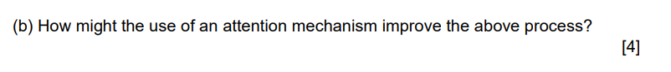
**Attention Mechanism: To improve the model’s ability to align input and output sequences, an attention mechanism can be added. This is because if the sequences become long, the model performance degrades. This mechanism helps the decoder focus on different parts of the input sequence while generating each token in the output sequence. Such as if the input sequence is what do you like?, the output is I like football. We will focus on you, I and like and football as they are related.
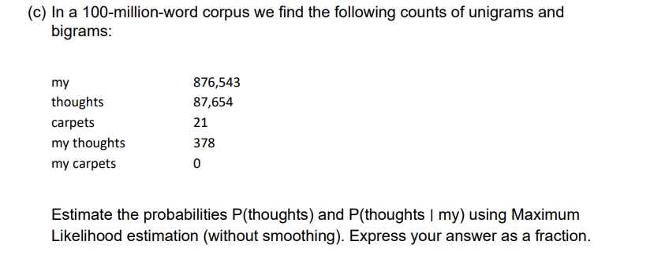
- P(thoughts):
  - Count of "thoughts" = 87,654
  - Total count of words = 100,000,000 (the size of the corpus)
P(thoughts) = Count("thoughts") / Total word count P(thoughts) = 87,654 / 100,000,000
- P(thoughts | my):
  - Count of "my thoughts" = 378
  - Count of "my" = 876,543 (context)
P(thoughts | my) = Count("my thoughts") / Count("my") P(thoughts | my) = 378 / 876,543
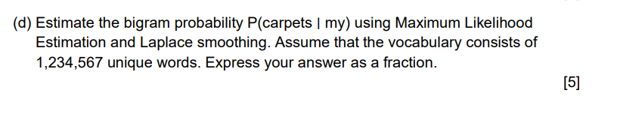
To estimate the bigram probability P(carpets | my) using Maximum Likelihood Estimation (MLE) and Laplace smoothing, you'll use the following formula with Laplace smoothing:
P(carpets | my) = (Count("my carpets") + 1) / (Count("my") + Vocabulary Size)
Here:
- Count("my carpets") is the count of the bigram "my carpets," which is 0 in your given data.
- Count("my") is the count of the unigram "my," which is 876,543 as previously calculated.
- Vocabulary Size is the total number of unique words in the vocabulary, given as 1,234,567.
Now, plug these values into the formula:
P(carpets | my) = (0 + 1) / (876,543 + 1,234,567)
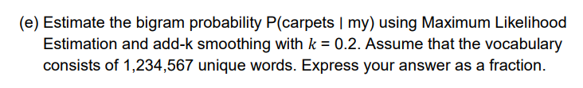
P(carpets | my) = (Count("my carpets") + k) / (Count("my") + k * Vocabulary Size)
Here:
- Count("my carpets") is the count of the bigram "my carpets," which is 0 in your given data.
- Count("my") is the count of the unigram "my," which is 876,543 as previously calculated.
- Vocabulary Size is the total number of unique words in the vocabulary, given as 1,234,567.
- k is the smoothing parameter, which is 0.2 in this case.
Now, plug these values into the formula:
P(carpets | my) = (0 + 0.2) / (876,543 + 0.2 * 1,234,567)
Now, let's simplify this fraction:
P(carpets | my) = 0.2 / (876,543 + 0.2 * 1,234,567)
Now, calculate the denominator:
P(carpets | my) = 0.2 / (876,543 + 246,913.4)
P(carpets | my) = 0.2 / 1,123,456.4
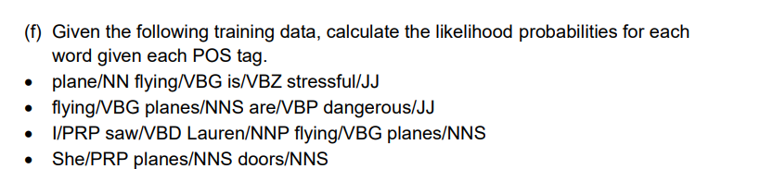
- Count the occurrences of each word with each POS tag in the training data:
- plane/NN: 1
- flying/VBG: 3
- is/VBZ: 1
- stressful/JJ: 1
- planes/NNS: 2
- are/VBP: 1
- dangerous/JJ: 1
- I/PRP: 1
- saw/VBD: 1
- Lauren/NNP: 1
- She/PRP: 1
- doors/NNS: 1
- Calculate the conditional probabilities for each word given each POS tag:
- P(plane|NN) = Count(plane/NN) / Count(NN) = 1/1 = 1.0
- P(flying|VBG) = Count(flying/VBG) / Count(VBG) = 3/3 = 1.0
- P(is|VBZ) = Count(is/VBZ) / Count(VBZ) = 1/1 = 1.0
- P(stressful|JJ) = Count(stressful/JJ) / Count(JJ) = 1/2 = 0.5
- P(planes|NNS) = Count(planes/NNS) / Count(NNS) = 2/2 = 1.0
- P(are|VBP) = Count(are/VBP) / Count(VBP) = 1/1 = 1.0
- P(dangerous|JJ) = Count(dangerous/JJ) / Count(JJ) = 1/2 = 0.5
- P(I|PRP) = Count(I/PRP) / Count(PRP) = 1/2 = 0.5
- P(saw|VBD) = Count(saw/VBD) / Count(VBD) = 1/1 = 1.0
- P(Lauren|NNP) = Count(Lauren/NNP) / Count(NNP) = 1/1 = 1.0
- P(She|PRP) = Count(She/PRP) / Count(PRP) = 1/2 = 0.5
- P(doors|NNS) = Count(doors/NNS) / Count(NNS) = 1/2 = 0.5
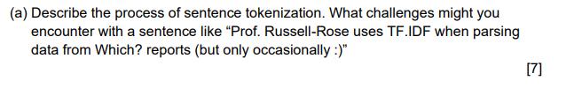
Sentence tokenization is the process of splitting a text into individual sentences. It's an essential step in natural language processing (NLP) and text analysis, as it allows you to work with sentences as distinct units of meaning. The process of sentence tokenization can generally be broken down into the following steps:
- Text Input: You start with a block of text, which can be a paragraph, a document, or any piece of text that contains sentences.
- Sentence Boundary Detection: The main task in sentence tokenization is identifying the boundaries between sentences. This involves finding punctuation marks and other cues that indicate the end of one sentence and the beginning of the next. Common sentence-ending punctuation marks include periods (.), exclamation points (!), and question marks (?). However, sentence tokenization also needs to consider abbreviations, initials, and other cases where a period does not necessarily indicate the end of a sentence.
- Handling Special Cases: Some sentences can be tricky to tokenize due to special cases, such as abbreviations, titles, or emoticons. In your example sentence, "Prof." is an abbreviation for "Professor," and the smiley face ":)" is an emoticon. Tokenization tools need to be aware of such cases to avoid incorrect splitting.
Challenges with the given sentence, "Prof. Russell-Rose uses TF.IDF when parsing data from Which? reports (but only occasionally :)", include:
- Abbreviations: "Prof." is an abbreviation for "Professor." Tokenization tools may need to be aware of common abbreviations and not split sentences incorrectly.
- Parentheses and Emoticons: The sentence contains parentheses and an emoticon ":)". These can be challenging as they don't represent traditional sentence boundaries but are often used to provide additional context or tone. Tokenizers may need to consider these as part of the surrounding sentence.
- Periods within Abbreviations: The abbreviation "TF.IDF" contains periods within it. Tokenizers should recognize that these periods are part of a single entity and not treat them as sentence-ending punctuation.
- Question Mark: The question mark in "Which?" indicates a question, but it's also part of a larger sentence. Tokenization tools need to understand when a question mark represents the end of a sentence and when it's part of a larger construct.
To handle these challenges, tokenization tools often rely on heuristics, rules, and sometimes machine learning models trained on large datasets. They take into account contextual information and language-specific rules to make informed decisions about sentence boundaries, abbreviations, and other complexities. However, tokenization is not always perfect and may require fine-tuning or manual adjustments for specific cases like the one you provided.

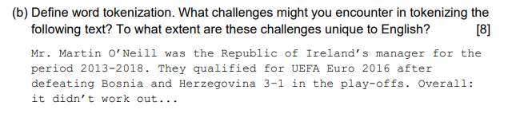
Word tokenization is the process of splitting a text into individual words or tokens. These tokens are typically separated by whitespace characters (such as spaces or tabs), and the goal is to segment the text into meaningful linguistic units, which are often words, but can also include punctuation and other symbols, depending on the specific tokenization rules.
Challenges in tokenizing the provided text:
- Apostrophes in Names: The name "Mr. Martin O’Neill" contains an apostrophe within the name. Tokenizers need to be aware of common name structures and should not split names like "O’Neill" into separate tokens.
- Hyphenated Words: In "Bosnia and Herzegovina," you have a hyphenated word. Tokenizers need to recognize hyphenated words as single tokens to preserve their meaning.
- Special Characters and Numbers: The text contains numbers (2013-2018, 3–1) and special characters (e.g., ellipsis "…"). Tokenizers must decide whether to treat these as separate tokens or part of adjacent words. For example, "3–1" could be tokenized as "3" and "–1" or kept as a single token.
- Abbreviations: In "UEFA Euro 2016," "UEFA" is an abbreviation. Tokenizers need to recognize common abbreviations and treat them as single tokens.
- Ellipsis: The ellipsis "…" can be treated as one token or split into three separate periods. The choice may depend on the specific tokenizer and the context in which the ellipsis is used.
- Sentence-Ending Punctuation: The text ends with "it didn’t work out..." where the ellipsis is followed by sentence-ending punctuation. Tokenizers must decide whether to treat "out..." as one token or separate it into "out" and "..." or "out" and "."
- Names and Capitals: Tokenizers also need to recognize proper nouns and maintain the capitalization of words that are names, titles, or acronyms.
Challenges in tokenization are not unique to English but can vary across languages due to language-specific rules, punctuation conventions, and naming patterns. However, the specific challenges mentioned here are not necessarily unique to English and can be encountered in other languages as well, especially those that use Latin script and similar punctuation rules. Tokenization tools for different languages may need language-specific rules to handle these challenges effectively.

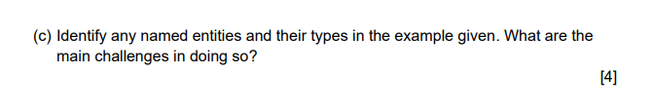
- Named Entity: Mr. Martin O’Neill
  - Type: Person (Personal Name) PER
- Named Entity: Republic of Ireland
  - Type: Geopolitical Entity (Country) GPE
- Named Entity: UEFA Euro 2016
  - Type: Event (Sports Event)
- Named Entity: UEFA
  - Type: Organization ORG
- Named Entity: Bosnia and Herzegovina
  - Type: Geopolitical Entity (Country)
- Named Entity: 3-1
  - Type: Goal score
Challenges in identifying named entities in this text:
- Apostrophes in Names: The name "Mr. Martin O’Neill" contains an apostrophe within the name.
- Variability in Names: People's names can vary widely in terms of format and structure. (e.g., "Mr."), initials, and special characters.
- Multi-Word Entities: Some named entities, like "Bosnia and Herzegovina," consist of multiple words.
- Abbreviations and Acronyms: The text mentions "UEFA Euro 2016," where "UEFA" is an abbreviation.
- Ellipsis: The ellipsis "…" at the end of the text is not a named entity, but its presence can complicate entity recognition.
- Variability in Entity Types: Named entities can belong to different types, such as persons, organizations, locations, and events.
- Context Dependency: Understanding the context of a word or phrase is crucial for accurate named entity recognition. For example, "Martin O’Neill" could refer to multiple individuals, and the context is needed to disambiguate.
- Language and Language Variations: The challenges in named entity recognition can vary across languages due to linguistic differences in naming conventions and grammatical structures. Different languages may require language-specific NER models and rules.

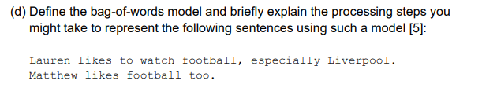

The bag-of-words (BoW) model is a simple text representation technique in natural language processing (NLP). It represents text as an unordered collection of words, ignoring grammar and word order but focusing on word frequency. Here are the steps to represent the given sentences using the BoW model:
- Tokenization: Break each sentence into individual words or tokens. In this case, tokenization would result in:
Sentence 1: ["Lauren", "likes", "to", "watch", "football", "especially", "Liverpool"]
Sentence 2: ["Matthew", "likes", "football", "too"]
- Vocabulary Creation: Create a vocabulary, which is a list of unique words present in the entire dataset. In this case, the vocabulary would include:
Vocabulary: ["Lauren", "likes", "to", "watch", "football", "especially", "Liverpool", "Matthew", "too"]
- Word Frequency Counting: For each sentence, count the frequency of each word in the vocabulary. Create a numerical vector for each sentence where each element represents the count of a word from the vocabulary. Sentence 1 BoW Representation: [1, 1, 1, 1, 1, 1, 1, 0, 0] Sentence 2 BoW Representation: [0, 1, 0, 0, 1, 0, 0, 1, 1]

Or in simple words, we can say that:
BoW = {“Lauren": 1 , "likes": 2, "to": 1 , "watch": 1 , "football": 2, "especially", "Liverpool": 1, "Matthew": 1, "too": 1]}

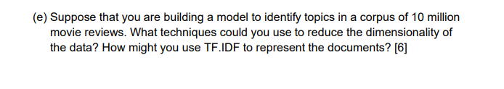
When dealing with a large corpus of text data like 10 million movie reviews, reducing the dimensionality of the data is essential for efficient and effective text analysis. Here are several techniques to reduce dimensionality and how to use TF-IDF to represent the documents:
1. TF-IDF Vectorization: TF-IDF (Term Frequency-Inverse Document Frequency) is a popular technique for representing text documents. It helps in reducing dimensionality by emphasizing important terms while downweighting common terms. Here's how to use TF-IDF:
- Calculate the TF-IDF scores for each term in each document. TF-IDF scores reflect the importance of a term within a document relative to its importance across the entire corpus.
- Each document is represented as a vector of TF-IDF scores for its terms. These vectors are typically sparse, with many entries being zero, which helps reduce dimensionality.
2. Feature Selection:
- Stop Words Removal: Common words like "the," "and," "is" don't provide much discriminative information. Removing them can reduce dimensionality.
- Low-Frequency Term Removal: Rare terms that appear only in a small number of documents may not contribute significantly to topic identification. Removing them can reduce dimensionality.
- High-Frequency Term Removal: Extremely common terms that appear in almost every document may not be informative. Removing them can reduce dimensionality.
3. Dimensionality Reduction Techniques:
- Principal Component Analysis (PCA): PCA can be applied to TF-IDF vectors to reduce their dimensionality while preserving as much variance as possible. However, PCA may not always perform well with text data due to its sparsity.
- Latent Semantic Analysis (LSA) or Latent Semantic Indexing (LSI): LSA is a technique that uses singular value decomposition (SVD) to find hidden semantic structures in a term-document matrix, effectively reducing dimensionality.
- Word Embeddings: Instead of using raw word counts or TF-IDF, you can use pre-trained word embeddings like Word2Vec or GloVe. These embeddings represent words as dense vectors in a lower-dimensional space, reducing the dimensionality of the input.

5. Clustering or Topic Modeling:
- Apply clustering techniques like K-Means or hierarchical clustering to group similar documents together. Then, represent each group as a single document, effectively reducing dimensionality.
- Use topic modeling techniques like Latent Dirichlet Allocation (LDA) to identify latent topics in the corpus. Each document can then be represented as a mixture of topics, which reduces dimensionality while capturing the main themes.
6. Hashing Vectorization:
- Hashing vectorization (e.g., HashingVectorizer in scikit-learn) uses a hash function to map terms to fixed-sized vectors. This reduces dimensionality but may lead to collisions (different terms mapping to the same vector).
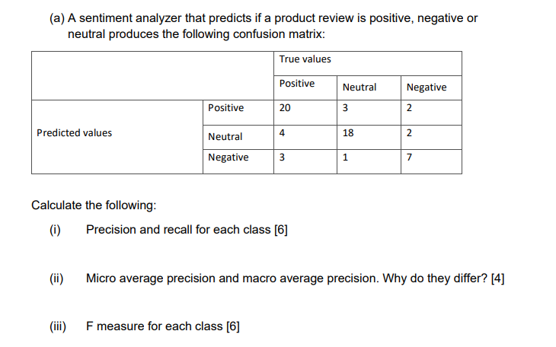
Let's calculate the requested metrics based on the given confusion matrix:
(i) Precision and Recall for Each Class:
- Positive Class:
  - Precision = True Positives / (True Positives + False Positives) = 20 / (20 + 3 + 2) = 20 / 25
  - Recall = True Positives / (True Positives + False Negatives) = 20 / (20 + 4 + 3) = 20 / 27
- Neutral Class:
  - Precision = True Positives / (True Positives + False Positives) = 18 / (18 + 4 + 2) = 18 / 24
  - Recall = True Positives / (True Positives + False Negatives) = 18 / (18 + 3 + 1) = 18 / 22
- Negative Class:
  - Precision = True Positives / (True Positives + False Positives) = 7 / (7 + 1 + 3) = 7 / 11
  - Recall = True Positives / (True Positives + False Negatives) = 7 / (7 + 2 + 2) = 7 / 11
(ii) Micro Average Precision and Macro Average Precision:
- Micro Average Precision: It is the precision calculated by considering all instances individually (micro-level) and then averaging them.
  - Micro Average Precision = (Total True Positives) / (Total True Positives + Total False Positives) = (20 + 18 + 7) / (20 + 18 + 7 + 5 + 6 + 4) = 45 / 60 = 0.75
- Macro Average Precision: It is the precision calculated for each class separately and then averaged.
  - Macro Average Precision = (Precision for Positive + Precision for Neutral + Precision for Negative) / 3 = ((20/25) + (18/24) + (7/11)) / 3 ≈ 0.728
Micro average precision considers all instances equally, while macro average precision treats each class equally and then takes the average. This is why they can differ, especially when classes are imbalanced.
(iii) F-Measure for Each Class:
The F-measure combines precision and recall into a single metric using the harmonic mean. The formula is F1 = 2 * (Precision * Recall) / (Precision + Recall).
- F-Measure for Positive Class:
  - F1 for Positive = 2 * (20/25 * 20/27) / (20/25 + 20/27) ≈ 0.77
- F-Measure for Neutral Class:
  - F1 for Neutral = 2 * (18/22 * 18/24) / (18/22 + 18/24) ≈ 0.78
- F-Measure for Negative Class:
  - F1 for Negative = 2 * (7/11 * 7/11) / (7/11 + 7/11) = 0.64
These are the F-measure values for each class.

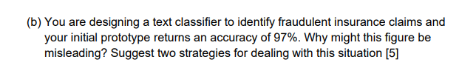

An accuracy of 97% in a text classifier for identifying fraudulent insurance claims may be misleading for several reasons:
- Class Imbalance: One of the common issues in fraud detection, including insurance fraud, is class imbalance. If the dataset contains significantly more legitimate (non-fraudulent) claims than fraudulent ones, a classifier can achieve high accuracy by simply predicting the majority class (non-fraudulent) most of the time. In such cases, high accuracy may not reflect the classifier's actual ability to detect fraud.
- Cost Sensitivity: Misclassifying fraudulent claims as legitimate can have severe financial consequences for insurance companies. Therefore, false negatives (fraudulent claims classified as legitimate) are more costly than false positives (legitimate claims classified as fraudulent). A high accuracy score may not take into account this cost imbalance, and a classifier that favors accuracy might not be suitable for the real-world problem.
To deal with this situation and address the potential issues with a high accuracy score:
- Confusion Matrix Analysis: Perform a detailed analysis of the confusion matrix to understand the distribution of true positives, true negatives, false positives, and false negatives. Calculate other evaluation metrics such as precision, recall, F1-score, and ROC-AUC to get a more comprehensive view of the classifier's performance. Focus on reducing false negatives (fraudulent claims missed by the classifier) even if it results in a lower overall accuracy.
- Resampling Techniques: If class imbalance is a problem, consider resampling techniques such as oversampling the minority class (fraudulent claims) or undersampling the majority class (legitimate claims). These techniques can help balance the dataset and improve the classifier's ability to detect fraud accurately.
- Cost-Sensitive Learning: Use cost-sensitive learning algorithms that explicitly consider the costs associated with misclassification. These algorithms can be trained to minimize the cost of false negatives rather than optimizing for accuracy. You can assign higher misclassification costs to false negatives to reflect the real-world consequences accurately.
- Feature Engineering: Carefully engineer features that are more discriminative for detecting fraud. Consider using domain-specific knowledge to create features that capture patterns or indicators of fraudulent behavior.
- Ensemble Methods: Utilize ensemble learning methods like Random Forests or Gradient Boosting, which often perform well on imbalanced datasets. These methods can improve the classifier's ability to capture complex relationships within the data.
- Anomaly Detection: Consider using anomaly detection techniques, such as Isolation Forest or One-Class SVM, which are well-suited for identifying rare events like fraudulent claims.
- Continuous Monitoring and Feedback: Deploy the classifier in a real-world setting and continuously monitor its performance. Collect feedback from domain experts and adjust the model as necessary to adapt to evolving fraudulent behaviors.

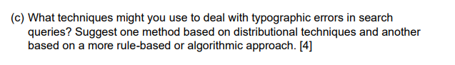
Dealing with typographic errors in search queries is essential for improving the user experience and ensuring that users receive relevant search results. Here are two techniques to handle typographic errors:

- Distributional Technique (Machine Learning-Based):

- Spell Checking and Correction Models: Employ machine learning-based models for spell checking and correction. These models can be trained on large corpora of text data to learn the distributional patterns of words and their common misspellings.
- Edit Distance-Based Methods: Algorithms like Levenshtein distance (edit distance) can measure the similarity between a query word and words in a dictionary. Suggest corrections for query words that are close in edit distance to valid dictionary words.
- Language Models: Utilize pre-trained language models like BERT or GPT to predict the most likely corrected word given the context of the query. Language models can capture semantic relationships and context, helping to suggest appropriate corrections.
- N-Gram Models: Build N-gram language models to predict the likelihood of specific word sequences. Suggest corrections based on the probability of a sequence given the query context.
- User Feedback: Collect user feedback on suggested corrections and use this data to continuously improve the spell checking and correction models.

- Rule-Based or Algorithmic Approach:
- Phonetic Algorithms: Use phonetic algorithms like Soundex or Metaphone to match query terms with dictionary words based on their phonetic similarity. This approach is especially helpful for identifying typographic errors that result in similar-sounding words.
- Keyboard Layout-Based Corrections: Consider the layout of the QWERTY keyboard (or other keyboard layouts) when suggesting corrections. Typos often occur due to adjacent keys being pressed accidentally. Suggest corrections that involve keys close to the ones pressed.
- Pattern Matching: Implement rule-based pattern matching techniques to identify common typographic errors, such as missing or repeated characters, transpositions, and substitutions.
- Regular Expressions: Create regular expressions to capture common typographic errors and correct them automatically. For example, you can use regular expressions to identify and correct common misspellings or formatting issues.
- Contextual Rules: Implement rules that consider the context of the search query. For example, if the query contains a known brand name, use specific rules to correct typographic errors related to that brand.
- User-Customized Rules: Allow users to define their own correction rules or preferences. Some users may have specific terminology or abbreviations they frequently use, and allowing them to customize corrections can enhance the search experience.
A combination of these techniques, along with continuous monitoring and improvement based on user feedback, can help create robust typo-tolerant search systems that effectively handle typographic errors and provide users with more accurate search results.

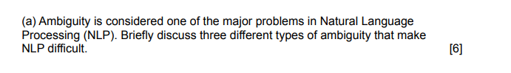

- Lexical ambiguity:
  - when a word has more than one meaning or part of speech. For example, the word “bank” can mean a financial institution or the edge of a river.
- Syntactic ambiguity
  - when a sentence can be parsed in more than one way. For example, the sentence “I saw a man with a telescope” can mean that I used a telescope to see a man, or that I saw a man who had a telescope
- Semantic ambiguity
  - when a sentence has more than one meaning due to the context or the scope of the words. For example, the sentence “He fed her cat food” can mean that he gave food to her cat, or that he gave her some cat food2.
- Pragmatic ambiguity:
  - when a sentence has more than one meaning due to the speaker’s intention or the listener’s inference. For example, the sentence “Can you pass me the salt?” can be interpreted as a request or a question2.

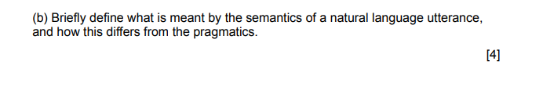
The semantics of a natural language utterance refers to its literal meaning or the way words and sentences are structured to convey information. It deals with the relationship between words and their meanings, focusing on the denotations and truth conditions.

Pragmatics, on the other hand, goes beyond literal meaning and considers the context, speaker's intentions, and how language is used in communication. It deals with implied meanings, indirect speech acts, and the impact of context on interpretation.

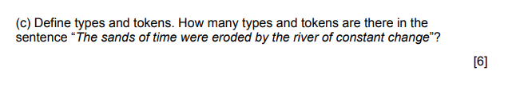

In linguistics, "types" and "tokens" are two concepts used to distinguish between different aspects of word usage:

1. Tokens: Tokens refer to the total number of individual words in a text, including repeated instances of the same word. In the sentence you provided, "The sands of time were eroded by the river of constant change," there are 10 tokens because there are 10 individual words.

2. Types: Types refer to the unique or distinct words in a text. In other words, types count each word only once, regardless of how many times it is repeated. To determine the number of types, you would identify all the different words in the sentence. In this sentence, there are 8 types: "The," "sands," "of," "time," "were," "eroded," "by," and "constant change."

So, in the sentence you provided, there are 10 tokens and 8 types.
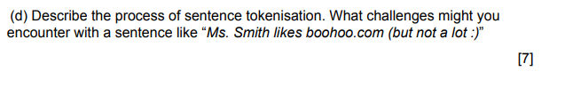

1. The input text is taken and parsed.
2. The sentence boundaries are detected between each sentence in the text.
3. Based on the sentence boundaries and the specific syntactic rules and filters applied, the separated different sentences are stored in a vector.
Challenges might be the following:
- The NLP tokenizer might have problems in parsing the prefixes of names such as Ms. Dr. etc. It has to have an understanding of various prefixes.
- It also has to understand the dots that some of them may be abbreviations and not end of sentences.
- It also has to handle URLs which may be incorrectly understood as EoS.
- It also has to understand the parantheses.
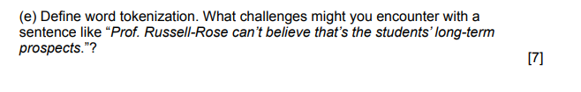
Word tokenization is the process of dividing a text into individual words or tokens. Each token typically corresponds to a word or a space-separated unit in a sentence. Challenges can arise in word tokenization when dealing with complex or non-standard word forms and contractions. In the sentence you provided, "Prof. Russell-Rose can’t believe that’s the students’ long-term prospects," there are several challenges:

1. **Abbreviations**: "Prof." is an abbreviation for "Professor." Some tokenizers may split it into two tokens, "Prof" and ".", while others may recognize it as a single word and retain the period. The choice depends on the tokenizer's rules and settings.

2. **Contraction**: The contraction "can't" is composed of two words, "cannot" and "can." A tokenizer needs to correctly identify contractions and split them into their constituent words, but some tokenizers might treat "can't" as a single token.

3. **Possessive Form**: The word "students'" contains an apostrophe, indicating possession. Tokenizers need to handle possessive forms correctly, recognizing that "students'" is a single word, not two separate tokens ("students" and "'").

4. **Hyphenation**: The word "long-term" is hyphenated. Tokenizers should keep hyphenated words together as single tokens to preserve their intended meaning.

5. **Quotation Marks**: If quotation marks are used, tokenizers should handle words within quotes as a single token to maintain their semantic integrity.

Addressing these challenges requires a tokenizer to be aware of common linguistic structures, abbreviations, contractions, and punctuation rules. Customizations and fine-tuning may be necessary to ensure accurate word tokenization, especially in cases with complex or non-standard language usage.
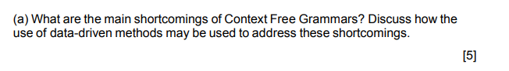
Context-Free Grammars (CFGs) are widely used in formal language theory and parsing, but they have several shortcomings, especially when applied to natural language processing (NLP). Data-driven methods can help address these shortcomings:

1. **Lack of Expressiveness**: CFGs cannot fully capture the complex structures and dependencies found in natural language, such as cross-serial dependencies and long-distance relationships. Data-driven methods, like probabilistic context-free grammars (PCFGs) or neural network-based models, can capture more intricate language patterns by learning from data.
2. **Ambiguity Handling**: CFGs often result in parse ambiguity, where a sentence can have multiple valid parse trees. Data-driven methods can employ probabilistic modeling to assign likelihood scores to different parses, allowing for more accurate disambiguation based on real-world language usage.
3. **Limited Context**: CFGs are inherently context-free and do not consider the broader linguistic context. Data-driven methods, such as recursive neural networks (RNNs) and transformer models, can incorporate richer context by considering words and phrases beyond immediate neighbors.

4. **Difficulty Handling Real-World Language**: CFGs struggle with handling phenomena like irregular verbs, idiomatic expressions, and morphological variations. Data-driven methods, with large corpora of real-world language data, can better adapt to and model these irregularities.

5. **Parsing Efficiency**: CFG parsers can be computationally expensive, especially for long sentences or grammars with high ambiguity. Data-driven methods can optimize parsing by leveraging statistical techniques and parallelization, making them more suitable for real-time or large-scale applications.
6. **Resource-Intensive Grammar Engineering**: Creating CFGs for specific languages or tasks often requires manual effort and expertise. Data-driven methods can automate the process of grammar induction or rule learning from data, reducing the burden of grammar development.
7. **Domain Adaptation**: CFGs designed for one domain may not perform well in another. Data-driven methods can adapt to different domains by fine-tuning on domain-specific data, making them more versatile for a wide range of NLP tasks.

In summary, while CFGs serve as a foundation for formal language theory, data-driven methods offer more flexibility, adaptability, and expressive power in addressing the complexities of natural language. They learn from real-world language data, allowing NLP systems to better capture the intricacies of human communication and overcome the limitations of context-free grammars.

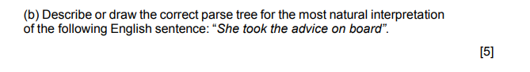
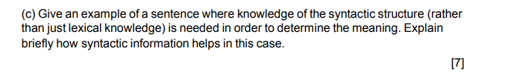

Consider the sentence: "I saw the man with the telescope."
In this sentence, syntactic structure is crucial for determining the meaning because it involves a potential ambiguity:
1. Without syntactic information: If you rely solely on lexical knowledge (the meanings of individual words), you might interpret this sentence as "I saw a man who had a telescope." In this case, "with the telescope" is understood as a description of the man.
2. With syntactic information: When you consider the syntactic structure, you realize that "with the telescope" is a prepositional phrase that modifies the verb "saw." The sentence means "I used the telescope to see the man." Here, the telescope is the tool or instrument used for seeing, not something the man possesses.

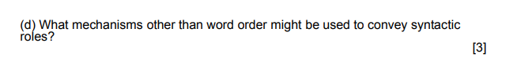
In addition to word order, languages can use various mechanisms to convey syntactic roles or the relationships between words in sentences. Some of these mechanisms include:
- Case Marking: Many languages use grammatical cases to indicate the syntactic role of nouns or pronouns in a sentence. For example, in German, "der Mann" (the man) becomes "den Mann" (the man, accusative case) when it functions as the direct object of a verb. Case marking helps clarify roles even when word order is flexible.
- Inflectional Endings: Inflections on verbs, adjectives, and nouns can provide information about their syntactic roles. For instance, verb conjugations can indicate the subject's person and number.
- Agreement: Agreement in gender, number, or person between different elements of a sentence can signal their syntactic relationship. For example, in Spanish, adjectives must agree in gender and number with the nouns they modify.
- Prepositions and Postpositions: Many languages use prepositions (before the noun) or postpositions (after the noun) to indicate the relationship between nouns and other elements in a sentence. For example, in English, "in" and "on" are prepositions used to convey spatial relationships.
- Particles and Clitics: Particles and clitics are small words or affixes that attach to other words and indicate their syntactic roles. For example, in Japanese, the particle "を" (pronounced "wo") marks the direct object of a verb.
- Semantic Roles: Some languages rely more on the semantic roles of words or phrases to convey meaning. Instead of relying solely on syntax, they use context and the inherent meaning of words to determine relationships.
- Word Morphology: Word morphology, including prefixes, suffixes, and infixes, can indicate syntactic roles or relationships within a word. For example, verb prefixes in Swahili indicate tense and aspect.
- Word Order Variations: While word order is an essential factor in conveying syntactic roles, some languages have more flexible word orders and rely on other mechanisms, like case marking or agreement, to maintain clarity in sentence structure.

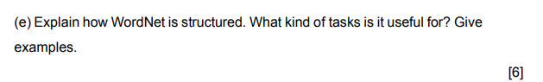
WordNet is a lexical database and semantic network of words and their meanings. It's structured as a hierarchical and taxonomic organization of words and senses, where words are grouped into synsets (synonym sets) based on their meanings and relationships. Here's how WordNet is structured:
- Synsets: Synsets are the central building blocks of WordNet. Each synset represents a set of words that are synonymous, or nearly synonymous, in a specific sense or meaning or abstract concepts. For example, the synset {dog, domestic dog, Canis familiaris} represents different words that refer to the same concept.
- Hypernyms and Hyponyms: Synsets are organized in a hierarchy, with hypernyms representing more general or broader concepts and hyponyms representing more specific or narrower concepts. For instance, "dog" is a hyponym of "mammal," which, in turn, is a hyponym of "animal."
- Meronyms and Holonyms: WordNet also includes relationships between parts and wholes. Meronyms represent parts or components of a whole, while holonyms represent the whole itself. For example, "finger" is a meronym of "hand," and "hand" is a holonym of "finger."
- Antonyms: WordNet includes antonyms for many synsets, helping to capture the opposites of words or concepts. For instance, "happy" is an antonym of "sad."
Tasks for word net
- Word Sense Disambiguation: It helps disambiguate word meanings in context. For instance, given the sentence "The bark of the tree is rough," WordNet can assist in determining whether "bark" refers to the sound a dog makes or the outer covering of a tree.
- Information Retrieval: It aids in improving search engine results by understanding synonyms and related words. For example, if a user searches for "automobile," WordNet can help retrieve documents containing "car" as well.
- Text Summarization: WordNet can be used to identify the most representative or central words in a text for summarization tasks.
- Machine Translation: It helps with mapping words between languages, especially when one language has multiple words for a concept and the other has only one.
- Natural Language Generation: In generating text, WordNet assists in selecting appropriate synonyms and related words to maintain variety and coherence.
- Semantic Similarity: WordNet can measure the similarity between words or concepts based on their positions in the hierarchy. This is useful for tasks like word recommendation and clustering.
- Lexical Resource for Research: Linguists and researchers use WordNet for studying word meanings, semantic relationships, and language evolution.
WordNet has been instrumental in various NLP applications and research, offering a rich source of semantic knowledge for understanding and working with natural language.

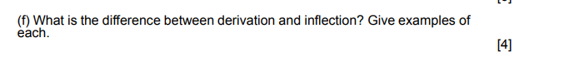
- Derivation involves adding affixes to base words to create new words with different meanings or word classes such as happy, unhappiness, friend, friendship
- Inflection involves modifying words to indicate grammatical information or relationships within a sentence, such as tense, number, case, etc. such as walk, walked, cat, cats.

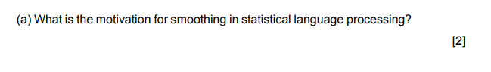
    - Data sparsity. Not all combination of words are available in text for training. This helps in avoiding zero probability.
    - Generalization to unseen data and stability.

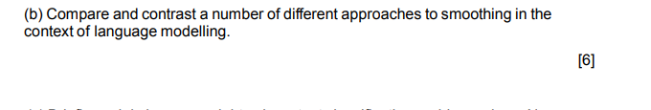
- Laplace (Add-One) Smoothing:
  - Approach: Laplace smoothing adds a constant (usually one) to the count of each event in the training data to ensure that no event has zero probability.
  - Pros: Simple, easy to implement, and works well for small datasets.
  - Cons: Tends to over-smooth and may not perform well with large datasets. It can result in an overestimation of probabilities for rare events.
- Lidstone (Additive) Smoothing:
  - Approach: Similar to Laplace smoothing, but instead of adding one, it adds a user-defined constant (k) to the count of each event.
  - Pros: Allows for fine-tuning the amount of smoothing, which can improve performance.
  - Cons: Performance still depends on the choice of the smoothing parameter (k).
- Kneser-Ney Smoothing:
- Approach: Uses a more sophisticated method to redistribute probability mass. It models the probability of a word based on its frequency in different contexts.
- Pros: Effective for large datasets and captures complex patterns in language.
- Cons: More complex and computationally intensive than simpler methods.
- Interpolation and Backoff:
- Approach: Combines multiple n-gram models of different orders, using lower-order models to estimate probabilities when data is sparse (backoff) or using a weighted combination of different order models (interpolation).
- Pros: Effective for capturing long-range dependencies and handling sparsity.
- Cons: Requires careful design of weights and can be computationally expensive with many models.

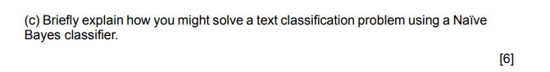
- Data Preparation:
  - Collect and preprocess your text data.
- Feature Extraction:
  - Represent the text data as numerical features that the Naïve Bayes classifier can use. The most common representation is the Bag of Words (BoW) or Term Frequency-Inverse Document Frequency (TF-IDF) vectors. Each feature represents the frequency or importance of a word in the text.
- Data Splitting:
  - Split your dataset into a training set and a test set. The training set is used to train the Naïve Bayes classifier, while the test set is used to evaluate its performance.
- Training the Naïve Bayes Classifier:
  - Choose the type of Naïve Bayes classifier based on your data. The two common variants are Multinomial Naïve Bayes (for discrete data like word counts) and Gaussian Naïve Bayes (for continuous data).
  - Calculate the class priors (the probabilities of each class) and class-conditional probabilities (likelihood) (the probabilities of each word given a class) using the training data.
- Classification:
  - For each document in the test set, calculate the posterior probabilities for each class using Bayes' theorem. Choose the class with the highest posterior probability as the predicted class.
- Evaluation:
  - Evaluate the classifier's performance using metrics like accuracy, precision, recall, F1-score, or ROC-AUC, depending on the nature of your classification problem (binary, multi-class, or multi-label).
- Tuning and Optimization:
  - Experiment with different preprocessing techniques, feature representations, and Naïve Bayes variants to optimize the model's performance.
  - Consider techniques like hyperparameter tuning and cross-validation to fine-tune the classifier.

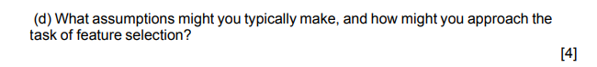
It assumes that predictors in a Naïve Bayes model are conditionally independent, or unrelated to any of the other feature in the model. It also assumes that all features contribute equally to the outcome

**Assumptions:**

1. **Independence Assumption:** Naïve Bayes assumes that features (words or tokens) are conditionally independent given the class label. This means that the presence or absence of one word does not affect the presence or absence of another word, given the class.

2. **Bag of Words (BoW) Representation:** Text is typically represented as a bag of words, disregarding word order and grammar. Each word or token is treated as a separate feature, and their order is not considered.

3. **Conditional Independence Assumption:** While Naïve Bayes assumes independence among features, it recognizes that features depend on the class label. So, the classifier models the conditional probabilities of words given the class.

**Feature Selection:**

1. **Feature Extraction:** One common approach to feature selection is to convert text data into numerical features using techniques like Bag of Words (BoW) or Term Frequency-Inverse Document Frequency (TF-IDF) representation. BoW represents each document as a vector of word frequencies, while TF-IDF additionally considers the importance of words in the corpus.

2. **Stop Words Removal:** Remove common stop words (e.g., "the," "and," "in") that often do not contribute meaningful information to the classification task.

3. **Stemming or Lemmatization:** Reduce words to their root forms to reduce feature dimensionality and capture variations of words as a single feature (e.g., "running" and "ran" reduced to "run").

4. **Feature Filtering:** Use statistical measures like document frequency, information gain, or chi-squared tests to rank or select the most informative features. This can help reduce noise and focus on relevant words.

5. **Feature Engineering:** Create new features based on domain knowledge or specific insights related to the classification task. For example, you might create features based on the presence of specific keywords or patterns.

6. **Dimensionality Reduction:** Techniques like Principal Component Analysis (PCA) or Latent Semantic Analysis (LSA) can be applied to reduce the dimensionality of the feature space while preserving important information.

7. **Regularization:** In some cases, you can use regularization techniques like L1 regularization (Lasso) to encourage feature selection during the model training process. This helps automatically select the most relevant features.

8. **Cross-Validation:** Use cross-validation to evaluate the performance of different feature selection techniques and hyperparameters to ensure that the selected features generalize well to unseen data.

The choice of feature selection techniques depends on the nature of the text classification task, the amount of data available, and domain-specific knowledge. It's often an iterative process, where you experiment with different methods and evaluate their impact on the classifier's performance.

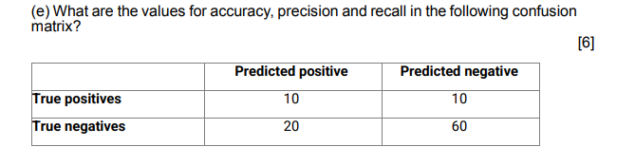

Accuracy: 70 / 100
Precision: 10 / 30
Recall: 10 /20

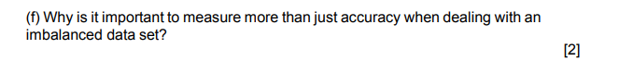

Measuring more than just accuracy is crucial when dealing with an imbalanced dataset because accuracy alone can be highly misleading and fail to provide a complete picture of a classifier's performance. Here are several reasons why measuring additional metrics is essential in such cases:
Class Imbalance Distorts Accuracy: In an imbalanced dataset, where one class significantly outnumbers the other, a classifier that predicts the majority class for all instances can achieve high accuracy simply by guessing the majority class. This can lead to a deceptively high accuracy score while failing to identify the minority class correctly.
Priority on Minority Class: In many real-world applications, the minority class (the one with fewer instances) is of particular interest or concern. Measuring additional metrics allows us to evaluate a classifier's ability to correctly identify and distinguish the minority class instances.
Understanding False Positives and Negatives: Imbalanced datasets often lead to an increased risk of false positives (predicting the minority class when it's not) or false negatives (failing to predict the minority class when it is). Metrics like precision, recall, and F1-score provide insights into these types of errors.
Balancing Trade-Offs: Different applications may have varying tolerance for false positives and false negatives. Measuring multiple metrics helps strike a balance between these trade-offs based on the specific needs of the task. For instance, in medical diagnosis, minimizing false negatives (missing a disease) might be more critical than reducing false positives (incorrectly diagnosing a disease).
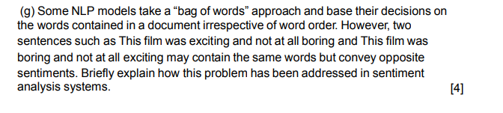
The problem of sentiment analysis systems treating two sentences with the same words but opposite sentiments differently, due to their "bag of words" approach, has been addressed using various techniques and features:

1. **N-grams:** Instead of treating individual words in isolation, sentiment analysis systems often consider word sequences or n-grams (e.g., bigrams, trigrams). This helps capture some degree of word order information. In the example you provided, the presence of specific word sequences like "exciting and not at all boring" and "boring and not at all exciting" can be indicative of sentiment.

3. **Dependency Parsing:** Dependency parsing considers the syntactic relationships between words in a sentence. It can help identify which words modify others and their roles. This can aid in distinguishing between sentences with similar words but different structures.

5. **Semantic Role Labeling:** Analyzing the semantic roles of words in a sentence can help identify which words are the main subjects, objects, or modifiers, providing a better understanding of the sentence's structure and sentiment.

6. Adding NOT_ after negation till next punctuation.

- **Machine Learning Models:** More advanced models, including deep learning models like recurrent neural networks (RNNs) and transformers, can capture complex relationships between words and consider contextual information, enabling them to better handle sentence structure and word order.

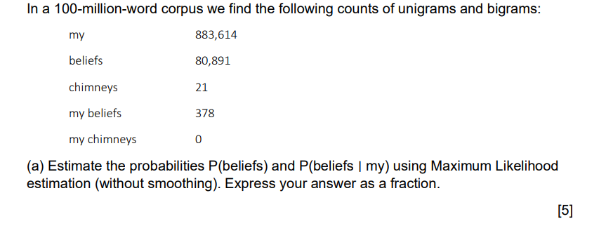
P(beliefs) 80891/100000000
P(beliefs| my) 378/ 883614
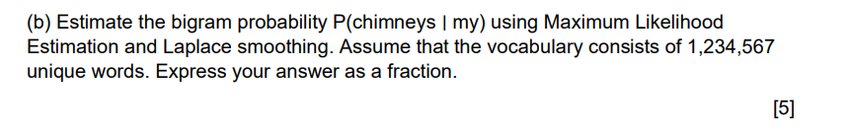
P(chimneys | my) = (0 + 1) / 883614 + 1234567

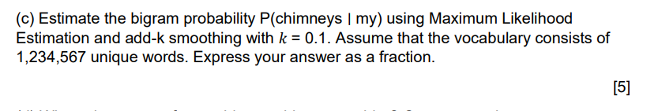
P(chimneys | my) = (0 + 0.1) / 883614 + 0.1 * 1234567
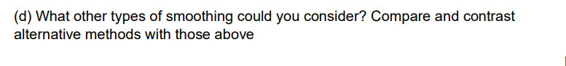

- Good-Turing Smoothing:
  - Method: Estimates the probability of unseen events based on the frequency of seen events. It redistributes probability mass from frequent events to rare ones.
  - Comparison: Good-Turing smoothing is more adaptive to data distributions and often outperforms fixed-constant smoothing methods like Laplace or Lidstone.
- Kneser-Ney Smoothing:
  - Method: Uses a more sophisticated method to redistribute probability mass. It models the probability of a word based on its frequency in different contexts.
  - Comparison: Kneser-Ney smoothing is effective for large datasets and captures complex patterns in language. It is considered one of the state-of-the-art smoothing methods.
- Interpolation and Backoff:
  - Method: Combines multiple N-gram models of different orders, using lower-order models to estimate probabilities when data is sparse (backoff) or using a weighted combination of different order models (interpolation).
  - Comparison: Interpolation and backoff techniques can capture long-range dependencies and handle sparsity but can be more computationally expensive than simple add-k or Good-Turing smoothing.
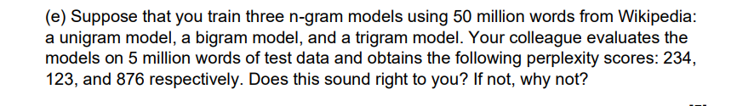
The perplexity scores for the three n-gram models, 234 for the unigram model, 123 for the bigram model, and 876 for the trigram model, raise some concerns and do not seem right. Perplexity is a measure of how well a language model predicts a given dataset, and typically, lower perplexity values indicate better model performance. Here's why these scores seem unusual:
- Unigram Model: A perplexity of 234 for a unigram model is relatively high. Unigram models are the simplest language models and tend to have higher perplexity values compared to higher-order models. However, perplexity in the hundreds suggests that the model struggles to predict the test data accurately.
- Bigram Model: A perplexity of 123 for a bigram model is lower than the unigram model's score, which is expected since bigram models consider the previous word in their predictions. However, a perplexity of 123 is still relatively high, and one would typically expect a better bigram model to have a lower perplexity score.
- Trigram Model: A perplexity of 876 for a trigram model is very high and unexpected. Trigram models incorporate even more context than bigram models, and a perplexity score in the hundreds or thousands is not typical for well-trained trigram models.
Possible reasons for these unusual perplexity scores could include:
- Data Quality: The training data might not be representative or clean, leading to issues in modeling language patterns.
- Model Complexity: The n-gram models may not be adequately complex to capture the intricacies of the language in the given dataset.
- Data Mismatch: There might be a mismatch between the training and test data, which can affect model performance.
- Data Size: The amount of training data (50 million words) may still be insufficient to build accurate n-gram models, especially for trigrams.
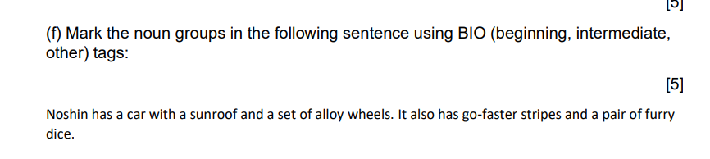
In the BIO (Beginning, Intermediate, Other) tagging scheme, we mark the noun groups in the given sentence as follows:
Sentence: "Noshin has a car with a sunroof and a set of alloy wheels. It also has go-faster stripes and a pair of furry dice"
- "Noshin" - B-NP (Beginning of Noun Phrase)
- Has – VBZ O
- "a - DT B-NP
- car" I-NP
- "a " - B-NP (Beginning of Noun Phrase)
- Sunroof – I-NP
- "a set" - B-NP (Beginning of Noun Phrase)
- "of alloy wheels" - I-NP (Intermediate of Noun Phrase)
- "It" - B-NP (Beginning of Noun Phrase)
- "go-faster stripes" - B-NP (Beginning of Noun Phrase)
- "a pair" - B-NP (Beginning of Noun Phrase)
- "of furry dice" - I-NP (Intermediate of Noun Phrase)

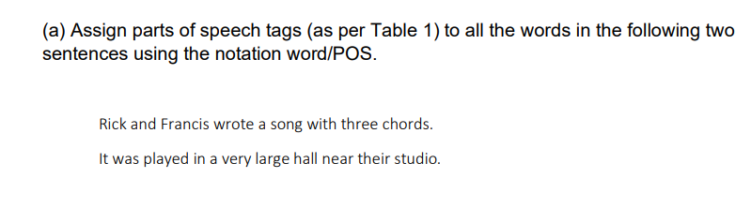

- Rick/NNP and/CC Francis/NNP wrote/VBD a/DT song/NN with/IN three/CD chords/NNS.
- It/PRP was/VBD played/VBN in/IN a/DT very/RB large/JJ hall/NN near/IN their/PRP$ studio/NN.
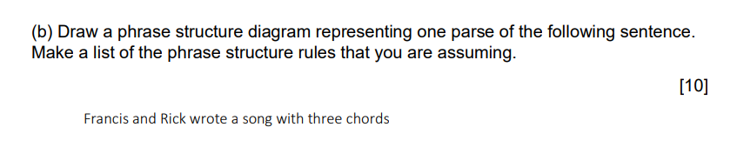

List of phrase structure rules assumed:
- S -> NP VP
- NP -> NP CC NP
- VP -> VBD NP
- NP - > NP PP
- NP -> DET NN
- PP -> IN NP
- NP -> CD NNS
- NP -> NN
- NN - > Francis | Rick | song
- CC - > and
- VBD - > wrote
- DET -> a
- IN -> with
- CD - > three
- NNS -> chords
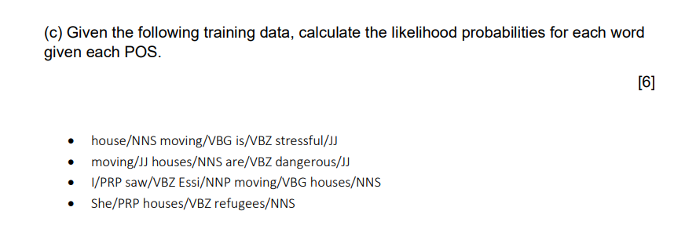
- house/NNS:
  - Count(NNS -> house) = 2 (from the first and fourth sentences)
  - P(house | NNS) = Count(NNS -> house) / Count(NNS) = 2 / 4 = 0.5
- moving/VBG:
  - Count(VBG -> moving) = 3 (from the first, second, and third sentences)
  - P(moving | VBG) = Count(VBG -> moving) / Count(VBG) = 3 / 4 = 0.75
- is/VBZ:
  - Count(VBZ -> is) = 1 (from the first sentence)
  - P(is | VBZ) = Count(VBZ -> is) / Count(VBZ) = 1 / 4 = 0.25
- stressful/JJ:
  - Count(JJ -> stressful) = 1 (from the first sentence)
  - P(stressful | JJ) = Count(JJ -> stressful) / Count(JJ) = 1 / 4 = 0.25
- houses/NNS:
  - Count(NNS -> houses) = 3 (from the second, third, and fourth sentences)
  - P(houses | NNS) = Count(NNS -> houses) / Count(NNS) = 3 / 4 = 0.75
- are/VBZ:
  - Count(VBZ -> are) = 2 (from the second and third sentences)
  - P(are | VBZ) = Count(VBZ -> are) / Count(VBZ) = 2 / 4 = 0.5
- dangerous/JJ:
  - Count(JJ -> dangerous) = 1 (from the second sentence)
  - P(dangerous | JJ) = Count(JJ -> dangerous) / Count(JJ) = 1 / 4 = 0.25
- I/PRP:
  - Count(PRP -> I) = 1 (from the third sentence)
  - P(I | PRP) = Count(PRP -> I) / Count(PRP) = 1 / 4 = 0.25
- saw/VBZ:
  - Count(VBZ -> saw) = 1 (from the third sentence)
  - P(saw | VBZ) = Count(VBZ -> saw) / Count(VBZ) = 1 / 4 = 0.25
- Essi/NNP:
  - Count(NNP -> Essi) = 1 (from the third sentence)
  - P(Essi | NNP) = Count(NNP -> Essi) / Count(NNP) = 1 / 4 = 0.25
- refugees/NNS:
  - Count(NNS -> refugees) = 1 (from the fourth sentence)
  - P(refugees | NNS) = Count(NNS -> refugees) / Count(NNS) = 1 / 4 = 0.25
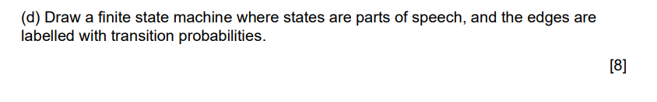

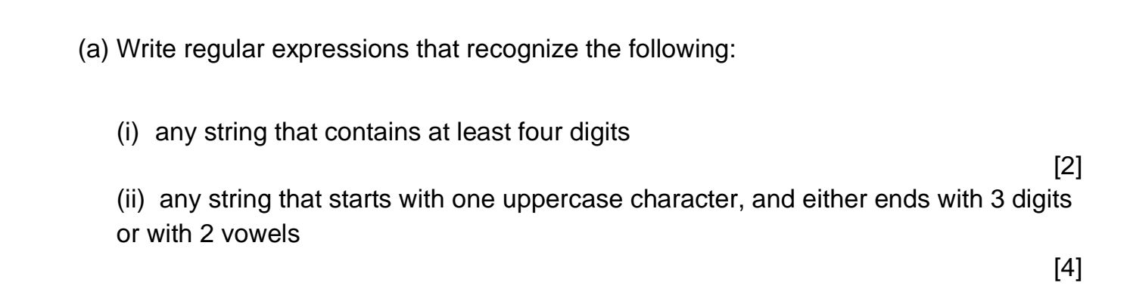
- .*\d.*\d.*\d.*\d.*
- pattern = r"\b[A-Z]\S*(\d{3}|[AEIOUaeiou]{2})\b"
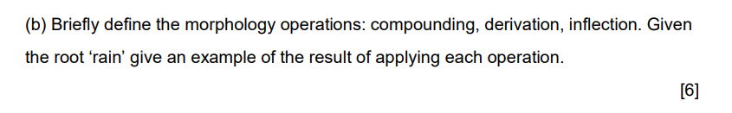
- Compounding:
  - Definition: Compounding is the process of forming new words by combining two or more independent words or morphemes. The resulting compound word often has a meaning that is related to the meanings of its components.
  - Example: Raincoat (combining "rain" and "coat") is a compound word formed by combining two independent words. It refers to a coat designed to protect against rain.
- Derivation:
  - Definition: Derivation involves adding prefixes or suffixes to a base word (the root) to create a new word with a different meaning or grammatical category.
  - Example: Rainy (adding the suffix "-y" to "rain") is derived from the root 'rain' and transforms it into an adjective, meaning "pertaining to rain."
- Inflection:
  - Definition: Inflection is the modification of a word to indicate grammatical information such as tense, number, case, person, mood, or gender. Inflectional changes typically do not change the core meaning of the word.
  - Example: Rains (adding the inflectional suffix "-s" to "rain") is used to indicate the third person singular form of the verb 'rain' in the present tense, as in "It rains today."

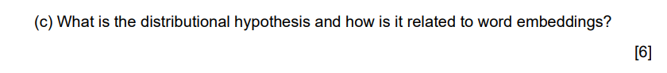
Distributional Hypothesis suggests that words with similar meanings tend to occur in similar contexts and have similar distributional patterns in a large corpus of text. In other words, words that are used in similar ways or appear in similar contexts are likely to be related in meaning. This hypothesis is the basis for many NLP techniques, including word embeddings.
Word embeddings are vector representations of words in a high-dimensional space, where each word is mapped to a point in this space. The key idea behind word embeddings is to capture the distributional information of words based on their co-occurrence patterns with other words in a large text corpus. Words that have similar meanings or are used in similar contexts are represented as points that are closer together in the vector space.
Here's how the Distributional Hypothesis is related to word embeddings:
- Learning Word Embeddings: Word embedding techniques, such as Word2Vec, GloVe, and FastText, are designed to learn word representations by analyzing the distributional patterns of words in large text datasets. These algorithms create word vectors that encode semantic information based on how words co-occur in sentences and documents.
- Semantic Similarity: Word embeddings allow us to measure the similarity between words in a meaningful way. Words that are semantically similar will have word vectors that are closer to each other in the embedding space. For example, in a well-trained word embedding model, the vectors for "cat" and "dog" will be closer together than the vectors for "cat" and "computer."

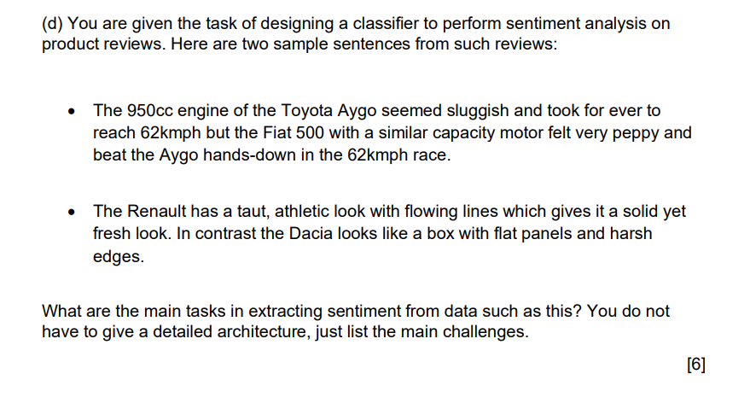
- Text Preprocessing: Cleaning and preprocessing the text data to remove noise, such as special characters, punctuation, and HTML tags, is a critical initial step.
- Tokenization: Breaking down the text into individual words or tokens to analyze and understand the sentiment of each word and its role in the sentence.
- Feature Extraction: Identifying and extracting relevant features from the text, such as keywords, phrases, or n-grams, that might carry sentiment information.
- Sentiment Classification: Developing a sentiment classification model that assigns sentiment labels (positive, negative, neutral) to reviews. This often involves using machine learning or deep learning techniques.
- Handling Negation: Dealing with negation is a challenge. For example, "not good" should be recognized as negative sentiment.
- Handling Sarcasm and Irony: Identifying and handling sarcastic or ironic statements that may convey sentiment in a non-literal way.
- Contextual Understanding: Understanding the context in which words or phrases are used. For example, "sluggish" in the context of a car engine might be negative, but in the context of a tortoise, it's unrelated to sentiment.
- Comparative Sentiment Analysis: Understanding the sentiment expressed in comparative statements like "better than," "worse than," or "similar to."
- Aspect-Based Sentiment Analysis: Identifying sentiment towards specific aspects or features of a product, as different aspects can have different sentiments.
- Handling Ambiguity: Dealing with ambiguous words or phrases that can have multiple meanings and, therefore, different sentiments depending on the context.
- Data Imbalance: Handling potential class imbalance issues, as product reviews may have an uneven distribution of sentiment labels.
- Domain Adaptation: Adapting sentiment analysis models to specific domains (e.g., automotive, electronics) to improve accuracy and relevance.
- Labeled Data Availability: Obtaining a sufficient amount of labeled training data for supervised sentiment analysis is often a challenge.
- Real-time Analysis: If real-time sentiment analysis is required, ensuring low latency and high throughput of the classification process.

